# Enriching context and enhancing engagement around datasets

Christian Herzog1,a, Daniel W Hook1,2,3,b, Mark Hahnel1,c, Stacy Konkiel1,d, and Duane E. Williams1,e

1Digital Science, London, N1 9XW, UK

2Department of Physics, Washington University in St Louis, St Louis, Missouri, USA

3Centre for Complexity Science, Imperial College London, London, SW7 2AZ, UK

(a<https://orcid.org/0000-0002-9983-0033>, b<https://orcid.org/0000-0001-9746-1193>, c<https://orcid.org/0000-0003-4741-0309>, d<https://orcid.org/0000-0002-0546-8257> e<https://orcid.org/0000-0002-2111-3413>)

## Introduction

The relationship between research, researchers and data is changing. Data has always played a critical role in scientific research, but in recent years it has taken centre stage not only for the sciences but also the social sciences, and it also now plays a significantly increased role in the humanities. This change is being driven by two key factors: First, the volume of research data that we have available is growing rapidly; and, second, our ability to process and analyse these data is growing as computers become faster and algorithms become more powerful. While many researchers welcome having more data to work with, the challenges in this new data-rich research world are not trivial.

The volumes of data that researchers have had to work with have been steadily on the rise for many years. Big Science projects such as those run by CERN have led the way in creating international infrastructures for sharing, processing and analysing large datasets. In a very real sense, the Internet itself is the result of the need for a global infrastructure to support science. Grid computing is another piece of infrastructure that was developed to support large international collaborations. Looking at the research world from a high enough vantage point and focusing on these large projects, however, misses the challenges generated by a second wave of advances.

While many researchers now have large volumes of data, the technologies developed to support the cutting-edge research projects of more than 20 years ago have become commoditised and are available to many researchers at a fraction of their original cost: storage is cheap and data transfer is fast. Technological issues are not, for the most part, at the centre of today’s challenges for our increasingly data-centric research world. Rather it is infrastructure of a different sort that now needs to be developed to support the research requirements of today.

In this short article, we discuss the needs of today’s research system for investment in two critical pieces of infrastructure that have not kept pace with their technological counterparts mentioned above. These missing pieces are information infrastructure and cultural infrastructure. Both of these challenges are addressed in Digital Science’s Rich Context project. Through this project, our aim is to provide ‘enriched’ information infrastructure around datasets. This information includes details of the approach to data stewardship, context of usage, code applied to the dataset in its production, as well as code applied to the data to derive further results or translate it for practical uses. All these factors add critical elements to the research infrastructure. The cultural infrastructure involves creating the incentives, triggers and frameworks that encourage the dataset stewards, experts and users to contribute to these critical information elements.

## Information Infrastructure

It is important to understand that any successful information infrastructure for research data will necessarily be deeply linked with the culture of research. For clarity of presentation, we have decided to present the challenges of the current information infrastructure and those of our current cultural norms separately. However, at each stage it is clear that each influences the other.

Information infrastructure can be defined as the collection of processes and artefacts that are foundational to today’s scholarly communications. A simplified model of scholarly communications would have artefacts like journals, journal articles, article metadata and citations. The processes are peer review and scholarly search.

The members of the Royal Society did not have today’s world in mind when creating *Philosophical Transactions*, the first ever scientific journal, 350 years ago. The infrastructures that have built up around research publication since that time are powerful and persistent through their ubiquity. Until very recently, we expected articles to be grouped into journals, and published on a particular date. We expect there to be a version of record that is in some sense the definitive record of a piece of research.

But heavy use of data in a research problem, or data shared collaboratively among colleagues across a research field, changes the dynamic around the research record. Fields that use data increasingly publish those data as a distinct output from a research article. Data has become a principal research output, but lacks the infrastructure that we have built up around the journal article (some experiments like “data journals” have had only limited success, given that a static and “flat” article is not a natural fit for publishing most data).

A dataset can change with time for many reasons: data may be added over time, corrections may be issued, and so on. In these cases, it may be appropriate to “version” the dataset (by issuing a persistent identifier for a point-in-time snapshot for the dataset, allowing subsequent changes to receive their own “versions”). But changes to a dataset may have a knock-on effect on the interpretation of the data and may fundamentally alter the research result that was originally reported. Moreover, in many fields “Big Data” is so central that it not only puts pressure on the community to establish an acceptable model of data publication, but also puts significant stress on how we read, interpret, and review research as a whole.

Many datasets are now so vast that we lack the ability as humans to consume them in an easy way. Visualisation technologies and other tools that allow us to interact with and sample data dynamically have received significant attention in recent years, and have helped with the interpretation of data in online environments. But it is simply impossible to reduce some types of data to a single figure or printable table, as would be the case for “traditional” journal publishing. By attempting to do so, we miss the essence of the data and risk failing to communicate data-driven conclusions accurately. This limitation of current publication formats (e.g. static PDF files for articles) is an issue that relates to the reproducibility crisis of modern research.

Peer review is another process that must change to account for data as a “first class” research object. Historically, peer reviewers have ensured that a piece of research is well-communicated and correct. This level of peer review is difficult to apply in the context of research data. If data is being published as a primary output, then it may be possible to perform a kind of peer review by applying some statistical tests to a sample of the data, or by using some other appropriate technique. However, it is no longer practical in most cases to set up a parallel experiment to reproduce data, as had been the case in years past. Across all contexts there are good reasons for these challenges: the experiment may be too costly to repeat, or the conditions of the original data collection may not be replicable (for example, surveying stress levels of the populace during a specific political event). In addition, ethical considerations such as the anonymity of those being surveyed may make certain types of data difficult to review. Thus, we must develop robust and accepted approaches to peer review, not only for data itself but also for those publications that are heavily based on data.

A number of publishing innovations have made journal articles more discoverable and accessible in recent years, such as preprint servers, DOIs, centralized search engines like Google Scholar and Dimensions, etc., however, these do not translate directly across to research data. Part of the reason for this is that there is a standard structure for an academic article (e.g. abstracts, keywords, etc), which is specifically designed around communication to humans. Solutions designed for data to date still have a long way to go in that regard. For example, the core fields required to create a valid DataCite record are identifier, creator, title, publisher, publication year and resource type[1]. All other data fields are optional (e.g. location, funder, subject, contributors) due to the fundamental uncertainty in what might constitute research data in the future. This flexibility limits how data can be discovered. It has taken some years for Web of Science, Google and others to introduce functionality to search for datasets in their discovery systems.

Clearly, technological infrastructure for data--or lack thereof--has huge implications for the discovery, peer review, citation practices, interpretation, and availability of data. These challenges are interconnected with challenges we face when thinking about the cultural infrastructure for data, as well.

## Cultural Infrastructure

There are two main aspects to cultural infrastructure: incentives and capability. Both of these aspects are strong drivers in how researchers engage with research data, and their behaviours relating to sharing it with others and making it available to external scrutiny.

Academics do not typically take up research careers for financial gain. Rather, they choose to dedicate their lives to understanding a specific problem partially in the hopes of discovering something that will make them “successful” by some measure. Success, of course, can be understood by looking at incentives for researchers. Researchers in many fields are promoted by publishing in specific high-impact journals, leading to funding success. Once you have demonstrated capability in this respect, there is a virtuous cycle. More funding leads to a greater chance of further publications in the “right” journals, which leads to more funding.

There are no such incentives here for sharing data. In this context, parting with the data that underpins your research gives rise to two concerns. Firstly, that someone may find an error in your work and discredit what you have done. Secondly, that someone else may not share their own data but will gladly reuse yours if you make it available, especially in fields where success is based on having more data to analyse. That may be the difference between having a career where you are well funded, promoted and have the ability to do research in the way that you want, and having to leave the field.

A further level of inequity exists in which data-related jobs are valued by the Academy. If a researcher happens to be particularly talented in working with data curation, data analysis or data processing, there is no track for recognising these talents. They are unlikely to be a first author on a publication in a major journal due to their data wrangling talents, and hence they have less of a chance of career progression than researchers who take a more traditional “publish or perish” path with their work as described above.

This set of perverse incentives means that people with the capability to handle data are often incentivised to leave research. Hence, not only do we have a problem of incentives in sharing and communicating data, but we also have a problem in retaining people who have the capability that we need to structure data so that it can be shared and built upon.

Capability for sharing data is the second aspect of the cultural challenge that academia continues to wrestle with. Making data available to others is generally accepted as a key part of the research communication process. However, there are certain established norms around when the data should be shared, and to what depth it is shared[2]; for example, in fields where human subjects research is prevalent, there is a much more conservative attitude towards open data than in fields like astronomy where data sharing is widely practiced, given that data can be collected by only a handful of observatories and telescopes worldwide.

In fields that are more applied, ensuring that data generated as a result of a commercial relationship is protected is crucial. In such fields, academics often have a better understanding of copyright, intellectual property rights and licences[3]. But outside of this context, there is a general lack of understanding of these issues and hence data are often not shared over concerns for a perceived legal barrier.

Other concerns are ethical—for example, should these data be shared if it might infringe the rights of the subjects of the research? Researchers are beginning to become aware that, through the use of algorithms, some data is not as well anonymised as it may first appear[4]. Anonymisation of data is a research field in and of itself[5].

Other concerns are simply practical—how do I make my data available in a way that is meaningful to others? The work associated with making a dataset generically machine-readable is challenging for many researchers, who tend not to be experts in data handling. The work associated with making a dataset human-understandable, reproducible and fully contextualised is often significant. However, governments and foundations have not necessarily prioritised these activities in their grant programs (though this is changing)[6],[7].

## Enriching context

While we at Digital Science cannot solve all the issues raised here, the points discussed do offer a blueprint for a generalised approach to handling and thinking about research data and what it means to be a researcher in the current research paradigm. We believe that a significant step in changing the perception of data and those who handle data is to increase the contextuality of research data.

There are two important pieces of infrastructure that need to be introduced. Firstly, a version of CredIT for research data[8], whereby all contributors to a dataset’s feeding and care over time are recognized, valued, and encoded in machine-readable ways. Such a system would be crucial in providing incentives towards data sharing, both making it possible to recognize “data wranglers” who could advance their career in-turn, and also by making it much easier for universities to track and reward those who are contributing towards the kinds of open access that are often discussed in university mission statements and faculty council decrees. The second piece of crucial infrastructure needed is, a set of tools that allow research data to be discovered and contextualised. In this section, we will focus on the latter challenge.

When we built Dimensions, the ability to contextualise any piece of research was a strong driver for our work[9]. The idea that all research happens in a particular place at a particular time, carried out by a set of people, some of whom may be affiliated with a research institution, gives a set of metadata that allows us the “weak context” of a piece of research. By “weak context” we mean that the context being provided gives no deep understanding of the context of an article to a non-expert and is essentially indistinguishable from standard metadata. But with modern data mining approaches, it is possible to add a “strong context”.

Strong contextualisation of research should provide a user with rich information about the research including funding, other research produced as part of the larger project (e.g. related publications, clinical trials, etc), and details of the research that was built on top of it. This information should also fit into, trends and graphical representations that offer a more complete, more rapid understanding of how research fits into the larger field, related fields, or the context of the publishing journal or supporting institution. For example, for a research article, we should be able to quickly understand how many researchers are in a related field, whether the field is growing, how old the field is, how much funding has been deployed in the field, which countries have provided that funding, whether the field has begun the translation to application through patents or clinical trials, or whether it has been used as a basis for the formulation of policy.

Context can also be offered in the data that we provide to understand the reach and influence of research.

Alternative metrics (“altmetrics”) are data from the social web that run orthogonal to classic citation measures, which can be seen to add significant context to an article – extending our understanding of how different cohorts of potential users of the research are engaging with it. For example, we can use altmetrics to understand if an article is being mentioned in the news, in which geographical regions it is being noticed, whether it is being used as part of a teaching syllabus, and many other kinds of public and non-traditional scholarly engagement. These data can then be visualized in creative ways to add instant additional context to engagement with a research article (see Fig. 1).

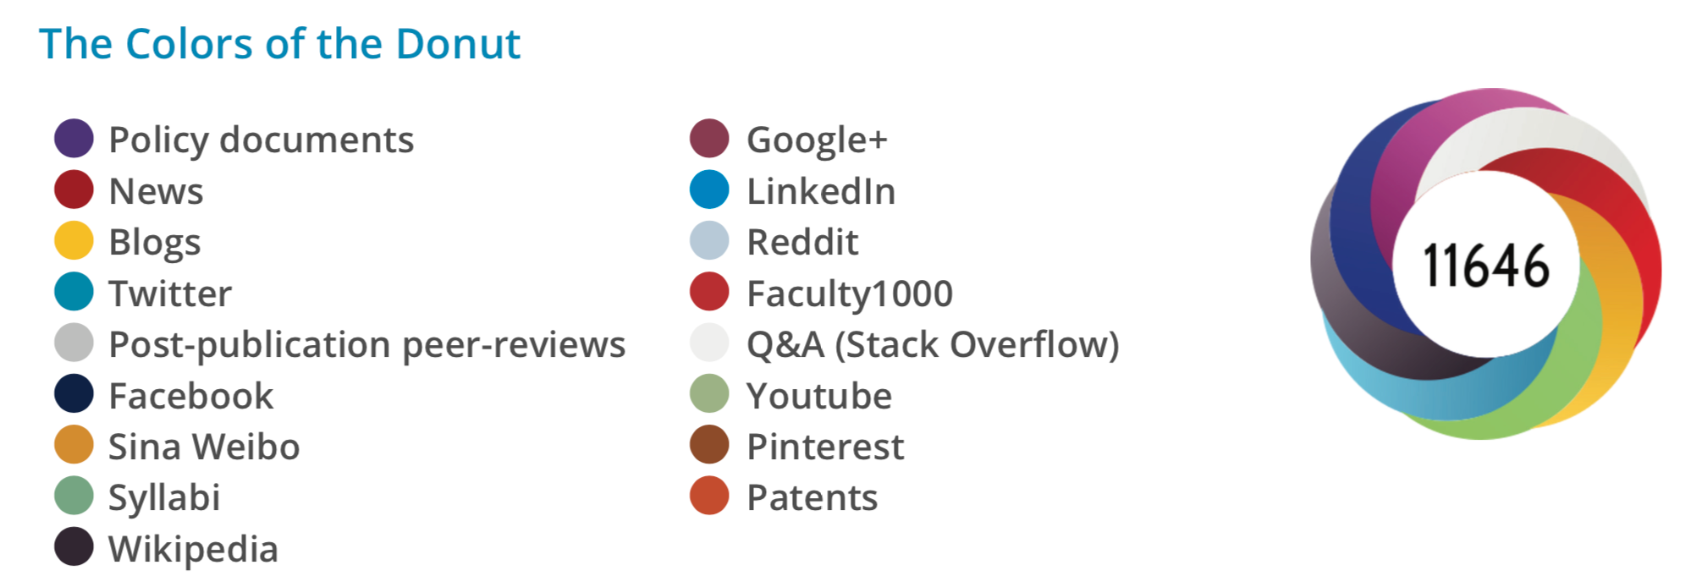

*Figure 1: Different types of context tracked by Altmetric.com for any research output.   
(Reproduced by permission of Altmetric.com)*

How datasets are used in research more broadly is another important piece of context that many data search engines lack. This is where the Rich Context project comes in. During the Rich Context project, we explored using Dimensions’ freely available public interface as a destination for researchers who seek context around datasets.

Such context for research data and its impacts could be offered in the form of in-app badges and other “signposts” that connect data with its larger context. Such a contextualizing badge could include not only the number of citations that the dataset has received, but also whether the data has been versioned (through Figshare’s repository metadata), discussed online (through Altmetric data), and what kind of tools and insights have been built on top of the data (through rich mining of full-text and citation data available in the ReadCube reference management corpus and in Dimensions).

Correctly developed and accepted by the community, this type of information can make a contribution to solving many of the problems highlighted in this article. If the correct contextual facets can be developed, then recognition would be easier to assign to those who have contributed to the process of creating and maintaining datasets. With greater context around them, datasets become easier to locate, understand and value. This in turn could lead to a broader evaluative environment and more engagement from academics.

Engagement across academia, however, is not uniform. Mechanisms need to be provided to engage data science-focused researchers from whom more details of their tools, scripts and codebooks could be drawn, adding further value to research data. At the same time, engagement tools need to allow data scientists to leverage this information so that it is valuable to them when they are the consumers of search results. These are subtly different use cases from those of standard researchers. By mining ever more open research systems wherein data is being analyzed (e.g. Gigantum, Github, etc), we can start to integrate these other crucial engagement contexts as well.

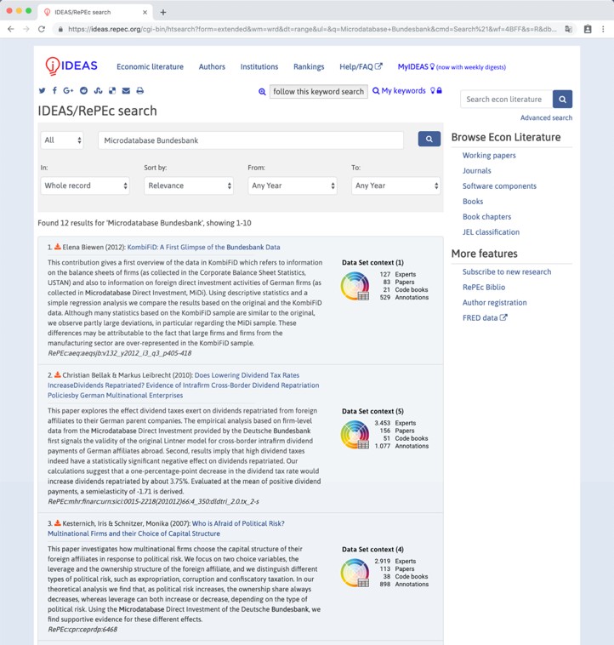

*Figure 2: Mock-up of a research data badge helping to contextualise a set of search results.*

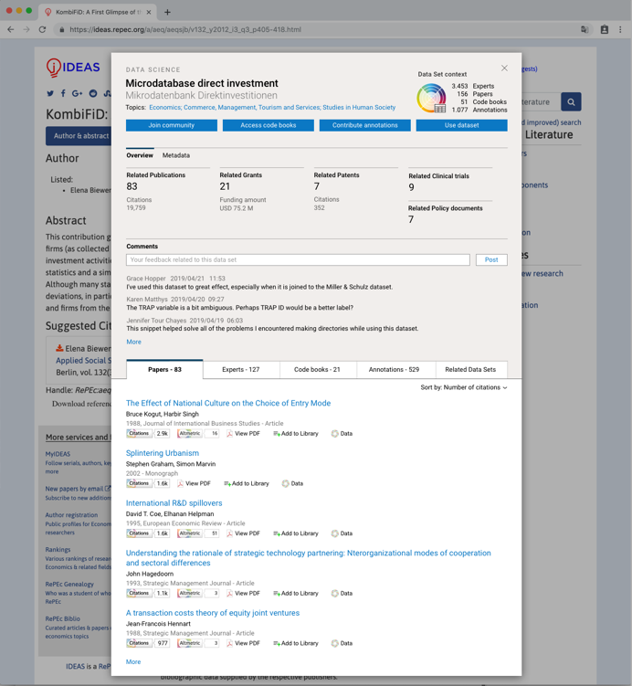

*Figure 3: Mock-up of a research data badge helping to contextualise a specific dataset.*

In Figures 2 and 3, we have mocked up some early thinking for how a contextualized research data badge could look. This visualisation is based on insights from the Rich Context project and uses data that could be mined from articles that use a specific dataset. In particular, we have suggested four initial facets of context that both data science-focused researchers and others could find helpful when viewing a dataset:

* **Experts** **who have made use of the data**, sourced from references made to the dataset in a professional context such as an industry whitepaper or policy document
* **Academics** that **cite the data**, mined from citation of the dataset or ancillary data in the peer reviewed literature
* **End users of the data**, sourced from code book references included in public code repositories
* **Enhancements of the data**, vis-à-vis annotations and comments made on the data in public forums.

In summary, we believe that, if deployed across the many environments in which researchers discover data (including and beyond Dimensions), the thinking behind the Rich Context project can overcome current infrastructural challenges to significantly extend the contextualisation of datasets. The number and variety of datasets in use in academia will certainly expand in the future, and we can only see data becoming even more central to contemporary research efforts. As such, it is critical to invest in robust infrastructures, not only to support the production and sharing of these data, but also to change the culture and evaluative environment around research data. It is only through initiatives such as these that we will be able to solve the vast and complex sociotechnical challenges that face academia today.

1. Support.datacite.org. (2019). *DataCite Metadata Schema 4.0*. [online] Available at: https://support.datacite.org/docs/schema-40 [Accessed 1 Jul. 2019].
2. Linek SB, Fecher B, Friesike S, Hebing M (2017) Data sharing as social dilemma: Influence of the researcher’s personality. PLOS ONE 12(8): e0183216. doi: 10.1371/journal.pone.0183216
3. Treadway, J., Hahnel, M., Leonelli, S., Penny, D., et al. (2016) The State of Open Data Report. [Online]. Available from: doi:10.6084/m9.figshare.4036398.v1 [Accessed: 1 July 2019].
4. Siddle, J. (2019). *I Know Where You Were Last Summer: London's public bike data is telling everyone where you've been*. [online] Vartree.blogspot.com. Available at: https://vartree.blogspot.com/2014/04/i-know-where-you-were-last-summer.html [Accessed 1 Jul. 2019].
5. Li, N., Li, T. and Venkatasubramanian, S. (2007). t-Closeness: Privacy Beyond k-Anonymity and l-Diversity. *2007 IEEE 23rd International Conference on Data Engineering*.
6. Rdmtoolkit.jisc.ac.uk. (2019). *Research Data Management Toolkit | Jisc*. [online] Available at: https://rdmtoolkit.jisc.ac.uk/plan-and-design/data-management-planning/ [Accessed 1 Jul. 2019].
7. Nnlm.gov. (2019). *Data Management Plan | NNLM*. [online] Available at: https://nnlm.gov/data/data-management-plan [Accessed 1 Jul. 2019].
8. Allen, L., Brand, A., Scott, J., Hlava, M., Altman, M., (2014) Nature 508, 312–313. doi:10.1038/508312a.
9. Hook, D.W., Herzog, C. and Porter, S.j. (2018) Front. Res. Metr. Anal. doi:10.3389/frma.2018.00023